

DEPARTMENT OF CIVIL ENGINEERING AND URBAN PLANNING

**Project 1** – Energy management

**Made by**

Giuseppe Amoroso, Max Bua, Mattéo Pheulpin, Joel Sand and Saga Sernekvist

**As part of the course**

M9 - Energy management in Buildings

2025-04-14

# Introduction

The goal of the project is to make a model of a simple building and examine its thermal properties and behaviour.

By describing the buildings properties

Not finished

# Description of the building

The chosen building is a studio apartment with one main living room and a bathroom. The building is located in France with the glazed wall facing south. The exterior walls are made up of 20cm concrete with an inner layer of 10cm insulation. The inner walls are made entirely of concrete with a thickness of 7,5cm. When choosing the values for the windows a normal 2-glass window was considered, with a thickness of 2,4cm. As illustrated in the building there is a door, which is made out of wood with a thickness of 5cm.

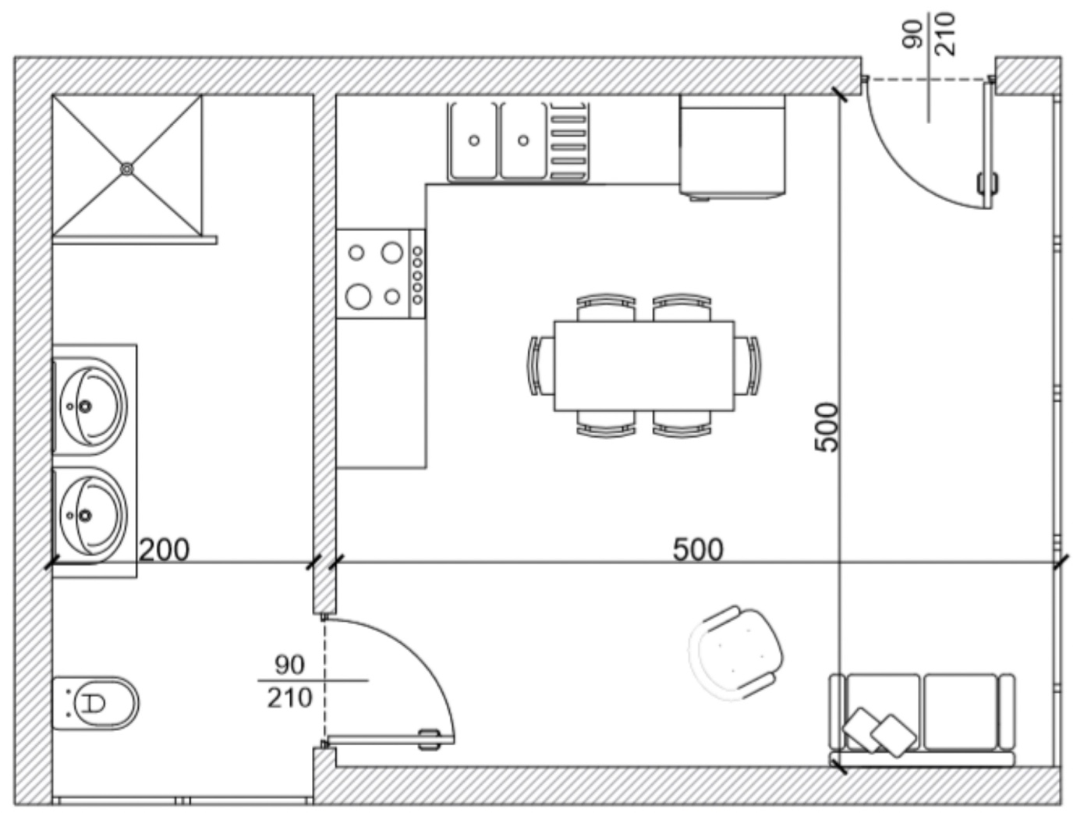

Figure 1: Floorsketch chosen building

Furthermore the entire building has been divided into two zones. As seen in the following table, the first zone is the living room/kitchen area with the other zone being the bathroom.

|  |  |
| --- | --- |
| *Area* | *Surface [* |
| *Zone 1 (Living room/kitchen)* | *25* |
| *Zone 2 (Bathroom* | *10* |

Table 1: Area chosen building

The total area of the apartment is 35 *.*

## Materials

The following materials with the following values were chosen for the building:

|  |  |  |  |  |  |
| --- | --- | --- | --- | --- | --- |
| Material | λ [W/m·K] | Specifik värme [J/kg·K] | |  | | --- | |  |  |  | | --- | | **Densitet [kg/m³]** | |
| Concrete | 1.4 | 960 | 2300 |
| Insulation | 0.027 | 840 | 50 |
| Wood | 0.17 | 2000 | 800 |
| Air | 0.025 | 1000 | 1.2 |
| Window | 1.4 | 1210 | 2500 |

Table 2: Material properties

# Hypothesis

The following hypothesis were used when modelling the building:

* The apartment is assumed to be part of an apartment complex, with apartments under and over. This assumption makes the heat transfer from the ceilings and floors neglectable.
* The building is located in Bron with the glazed wall facing south.
* Neglect long wave radiation because
* We assume no heat transfer through the east wall, as the corridor has a similar and stable temperature.
* We consider the door between the two rooms to be opaque to radiation, meaning no radiative heat transfer occurs through it.

# Model

The three fundamental principles of thermodynamics were used when modelling our system. These are illustrated below and explained with the following equations.

: Energy conservation

Direction and value of heat

Figure 2: Fundamental thermodynamic principles

In the picture above is a heat flow source, meaning that we inject energy without changing the flow.

is a temperature source that influences the system's temperature without being affected by the system itself. This means that b₁ acts as a fixed temperature reference or setpoint, such as a heating or cooling function.

represents the temperature at a node.

q is the flow of a branch.

G represents the thermal conductivity.

e₁ is the temperature difference across a thermal element, and it drives the heat flow.

With these things in mind, it is now possible to make a thermal model out of our chosen building.

# Thermal Model

The previously described building is depicted using nodes and flows by the following model. In the thermal model, each material is depicted using two resistances and a node. The nodes correspond to the temperatures in volumes, points or surfaces. In this case the temperatures in the air, materials in walls and windows and set point temperatures. The branches correspond to the heat flow rate between the temperature nodes.

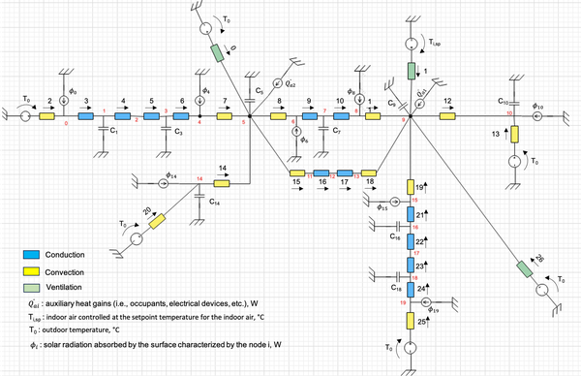

Figure 3: Thermal model

As shown on the left side of the model the colours have the following meaning

* The thermal conductivities with **conduction** are in blue
  + **Convection** is in yellow
  + **Ventilation** is in green
* The nodes (can´t tell from the bad resultion of the picture) are the temperature for the bathroom and the living room/kitchen

If there is time, smaller picture of part of the thermal model with clearer description

The volumetric flow rate of the air, , with the following equation:

Where ACH is the air changes per hours, 1/h,  is the volume of the air,  and 3600 is the number of seconds in one hour.

# Controller

The model utilizes a proportional heater, which is a simple representation of a controller.

It works by changing the heat flow rate  in order to controll the indoor temperature to its setpoint temperature

The Kp value, the proportional gain of the controller, when = 10,000, it represents an almost perfect controller that corrects temperature deviations instantly. However, such a high gain may not be realistic in practice, as it can lead to instability or oscillations.

# Steady state model

In order to determine the temperatures at the nodes and the heat flows along the branches the Differntial Algebraic Equations needed to be solved.

𝐺 is the conductance matrix, a diagonal matrix of size × , where is the number of branches.

𝜃 is the temperature vector of size , where corresponds to the number of temperature nodes in the model.

𝑞 is the heat flow vector, also of size , representing the heat transfer through each branch.

𝐴 is the incidence matrix, with dimensions × ,. It describes how temperature nodes are connected by directed branches, i.e., how heat flows between nodes.

𝐶 is the thermal capacity matrix, a diagonal matrix of size , × ,, assigning thermal capacity to each node.

𝑏 is the temperature source vector, of size , representing imposed temperature differences across branches.

𝑓 is the heat flow source vector, of size ,, representing external heat inputs directly into nodes.

# Steady state model

Matrix A defines the direction of flows between nodes. The rows correspond to individual flows, while the columns represent each node. A value of 1 indicates that a node receives the flow, whereas -1 signifies that the flow is leaving the node.

Matrix G is a square matrix where each row and column correspond to a specific flow. It is a diagonal matrix, with each diagonal element representing the conductance (G-value) of the respective flow. The following equations are used for this:

and

For the ventilation, the conductance for ventilation/infiltration is calculated using the following equation

With being the density of the air, the volumetric flow rate of the air is and  is the specific heat capacity of the air.

Similarly, matrix C shares the same structure as matrix G, but instead of representing flows, its rows and columns correspond to nodes. The diagonal elements of C represent the capacity at each node:

S

Vector b is a column vector with as many rows as the number of flows. It represents the external temperature sources, which are the only temperature sources in the system. The values in b correspond to the external temperatures. If a flow is influenced by an external temperature source, the corresponding value in b will be the external temperature for that flow.

The vector f consists of rows, each corresponding to a different node. It represents the external flows at each node. The value of each entry in the vector corresponds to the size of the external source at that node. If the node has no external source, the value is 0.

## Auxilairy heat gain

The auxiliary heat gains, , are added to each of the zones and represent the heat flow from the inhabitants and also heat gain from cooking and electronics. The heat gain from the inhabitants was estimated at 90 W.

Sensible Heat Gain (SHG) and Latent Heat Gain (LHG) in relation to human activities.
Source: ResearchGate (https://www.researchgate.net/figure/Sensible-Heat-Gain-SHG-and-Latent-Heat-Gain-LHG-in-respect-of-human-activities_tbl1_327228047)


Figure 4: Sensible Heat Gain (SHG) and Latent Heat Gain (LHG) in relation to human activities.

Heat gain from cooking and electronics was estimated to 70 W. With these matrices implemented it is possible to perform the stead state calculations.

# Optimization

# Dynamic model

The dynamic model uses a weather file to simulate the energy consumption and the temperature over time.

To better understand how the HVAC system affects the chosen building three different simulations have been performed. The first one being when the HVAC system was completely turned off. By setting the the following graphs were plotted.

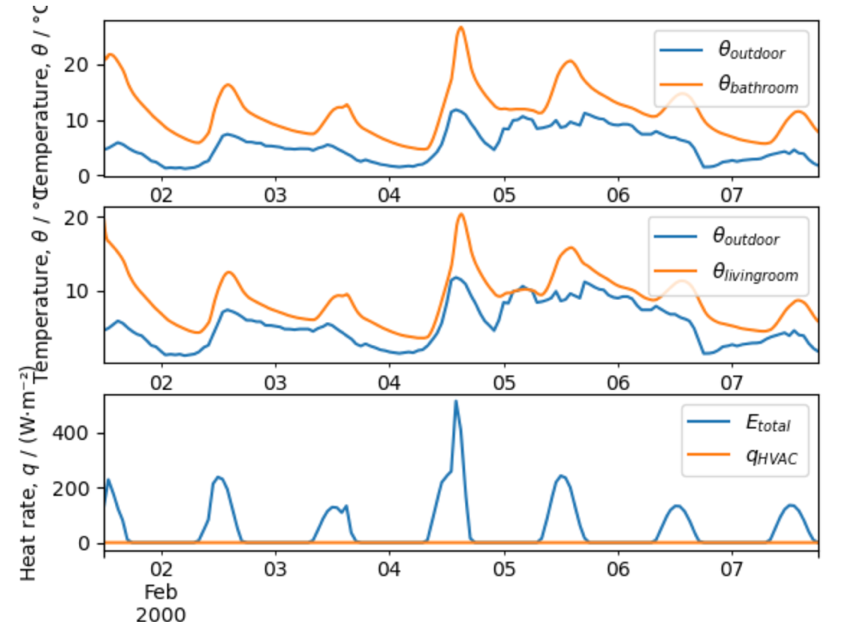

To be sure that the system is turned off, the heat rate was plotted, the bottom graph. In this graph the orange line shows that there is not any heat rate from the HVAC-system, meaning that the simulation was successful.

## Kp-values

To make sure that our simulation does not experience to much instability, whilst not having to much variation, different Kp-values were tested. The chosen period for this experiment was in februari.

### **Kp=250**

Firstly, Kp was set to 250 and the following graph was obtained.

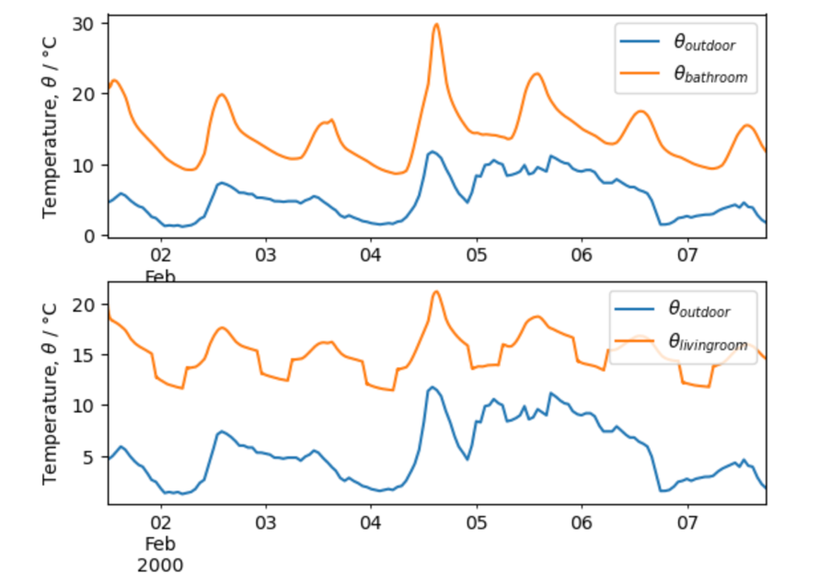

As mentioned earlier the building only has a controller in the living room. Which makes this the room experiencing the biggest changes when changing the values of Kp. When set to Kp=250 the room still experiences big differences in temperature, indicating that the value should preferably be higher.

### **Kp=500**

When increasing the Kp value further to a value of 500 the following graph was achieved:

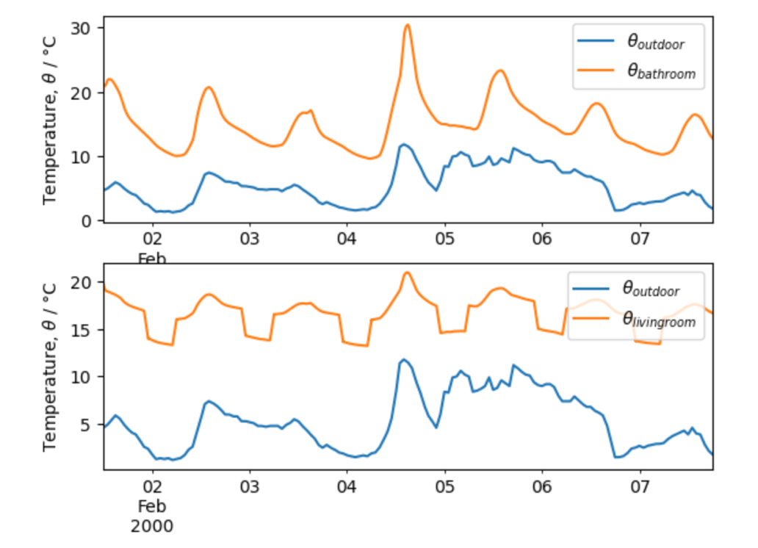

In this case the differences are smaller and more stable over the days. Indicating that a higher value is more preferable. When comparing the temperature with the one in the room in the bathroom it is also clear that the controller is helping to achive a more stable climate.

### **Kp=100**

Lastly, the value for Kp was set to 100. During this simulation the room experiences a lot of variations in temperature.

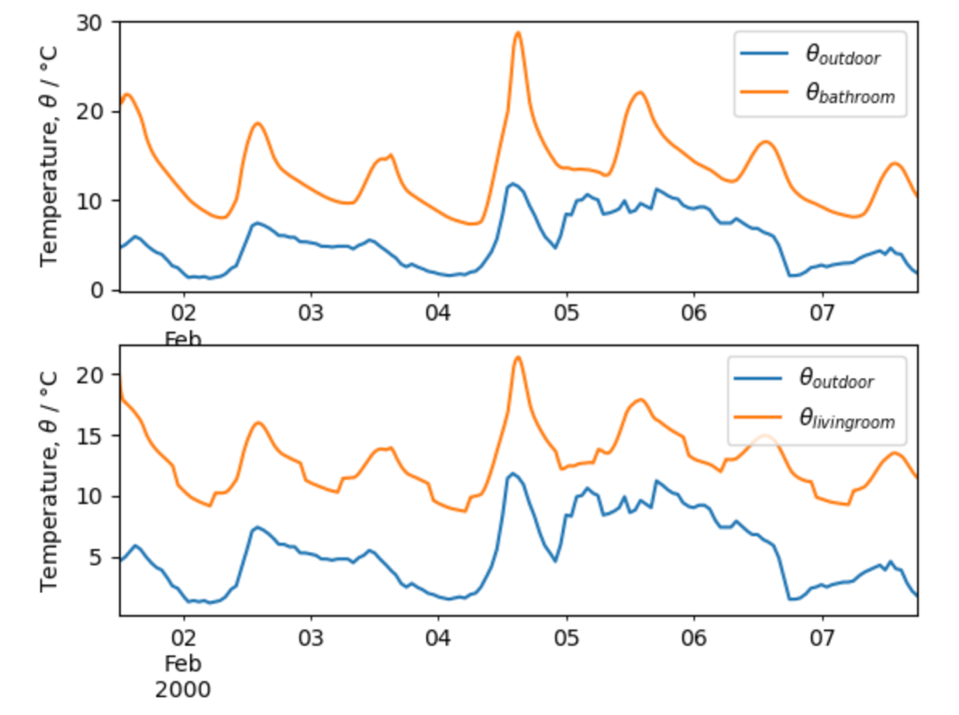

When looking at the difference between the exterior and interior temperature for the case with the controller the difference is very small, indicating that the controller is of a very small importance.

With these tests being performed it is concluded that the preferable value for Kp is 500. This is the value that will be used during the simulations of the improvements

## Optimization

The following changes has been made in order to better analyze different improvements of the current model:

* Placing the insulation externaly
* Doubling the amount of concrete in the external walls
* Doubling the amount of insulation

The different modifications were made for both a period during winter and one during summer. In this optimization the focus was on the energy consumption of the building. The results of all the simulations have been summarized and displayed in the following table.

|  |  |  |  |  |
| --- | --- | --- | --- | --- |
| Variation | Time of year | Simulation period | Heating energy consumption | Cooling energy consumption |
| Original | Winter |  | 137851 |  |
|  | Summer |  |  | 153240 w |
| External insulation | Winter |  | 137851 |  |
|  | Summer |  |  | 153240 |
| Double thickness concrete (exterior wall) | Winter |  | 137851.454254703 |  |
|  | Summer |  |  | 153240 |
| Double thickness insulation | Winter |  | 137851.4542547034 |  |
|  | Summer |  |  | 153240 |

All the values become the same, even when making really drastic changes

Increased concrete to 0.3 meters.